







UID /legal/

ReadySetResource.com

Contents

9.1 - Home 3

9.2 - Terms and Conditions of Use 4

9.3 - Copyright Policy 5

9.4 - Privacy Policy 6

9.5 - UID /legal/ Work Log 7

# 9.1 - Home

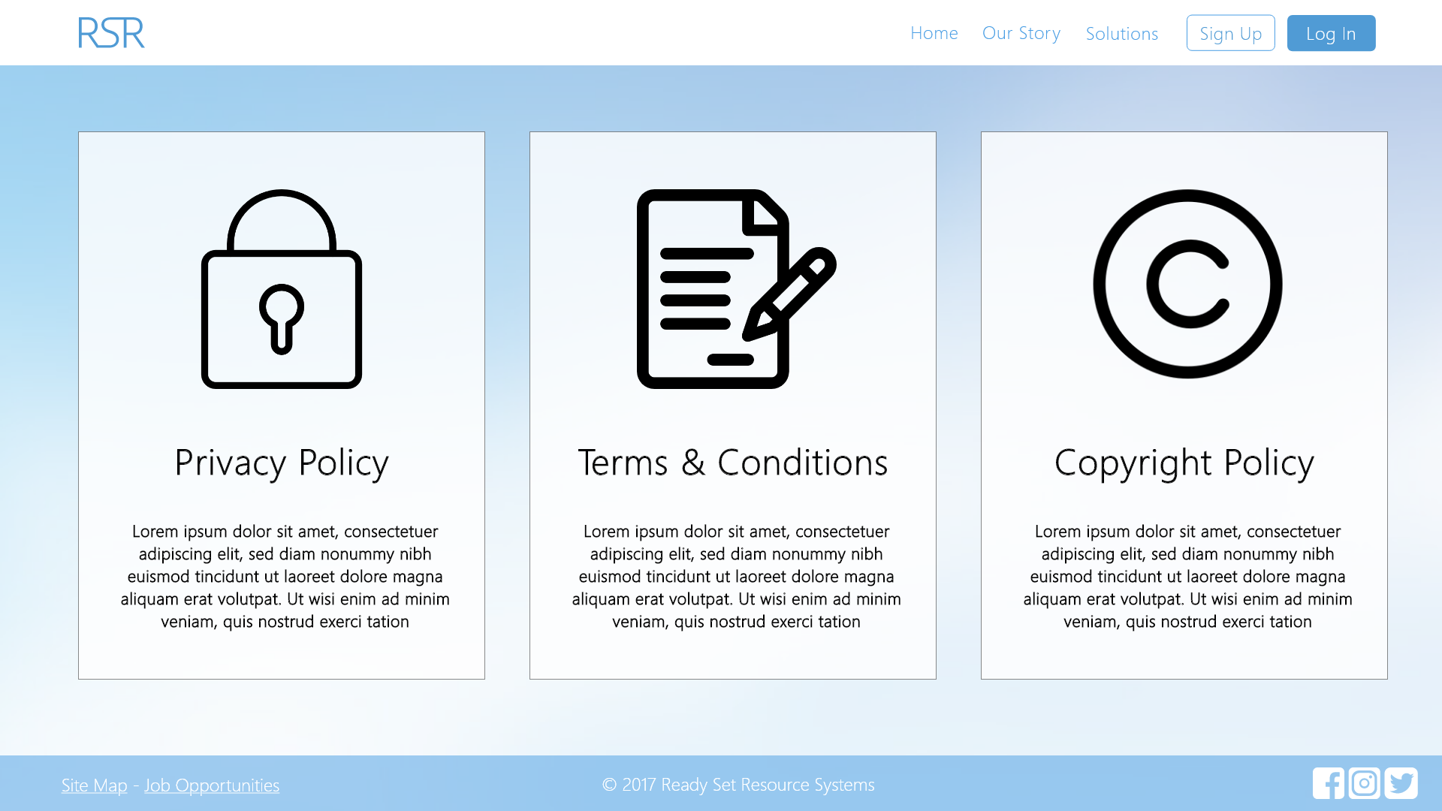

Input Permissible: None

Error Messages: None

# 9.2 - Terms and Conditions of Use

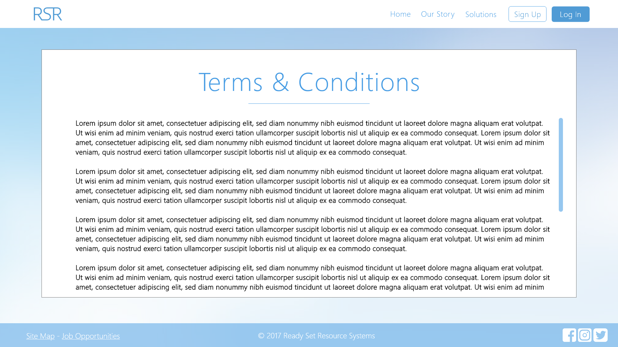

Input Permissible: None

Error Messages: None

# 9.3 - Copyright Policy

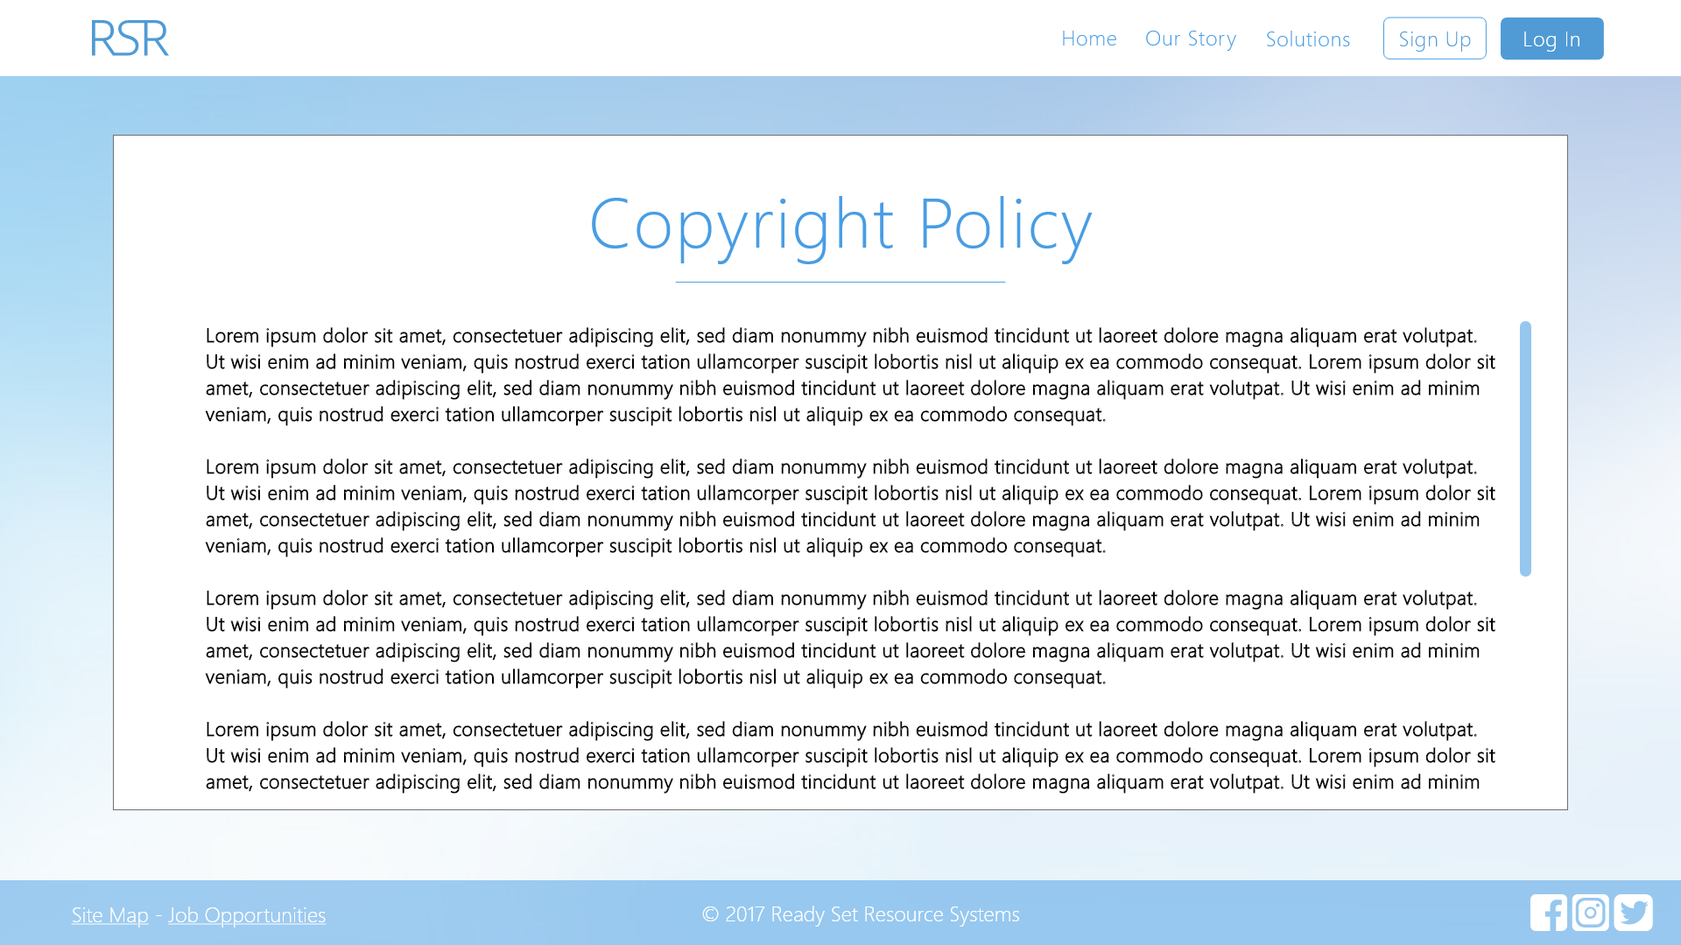

Input Permissible: None

Error Messages: None

# 9.4 - Privacy Policy

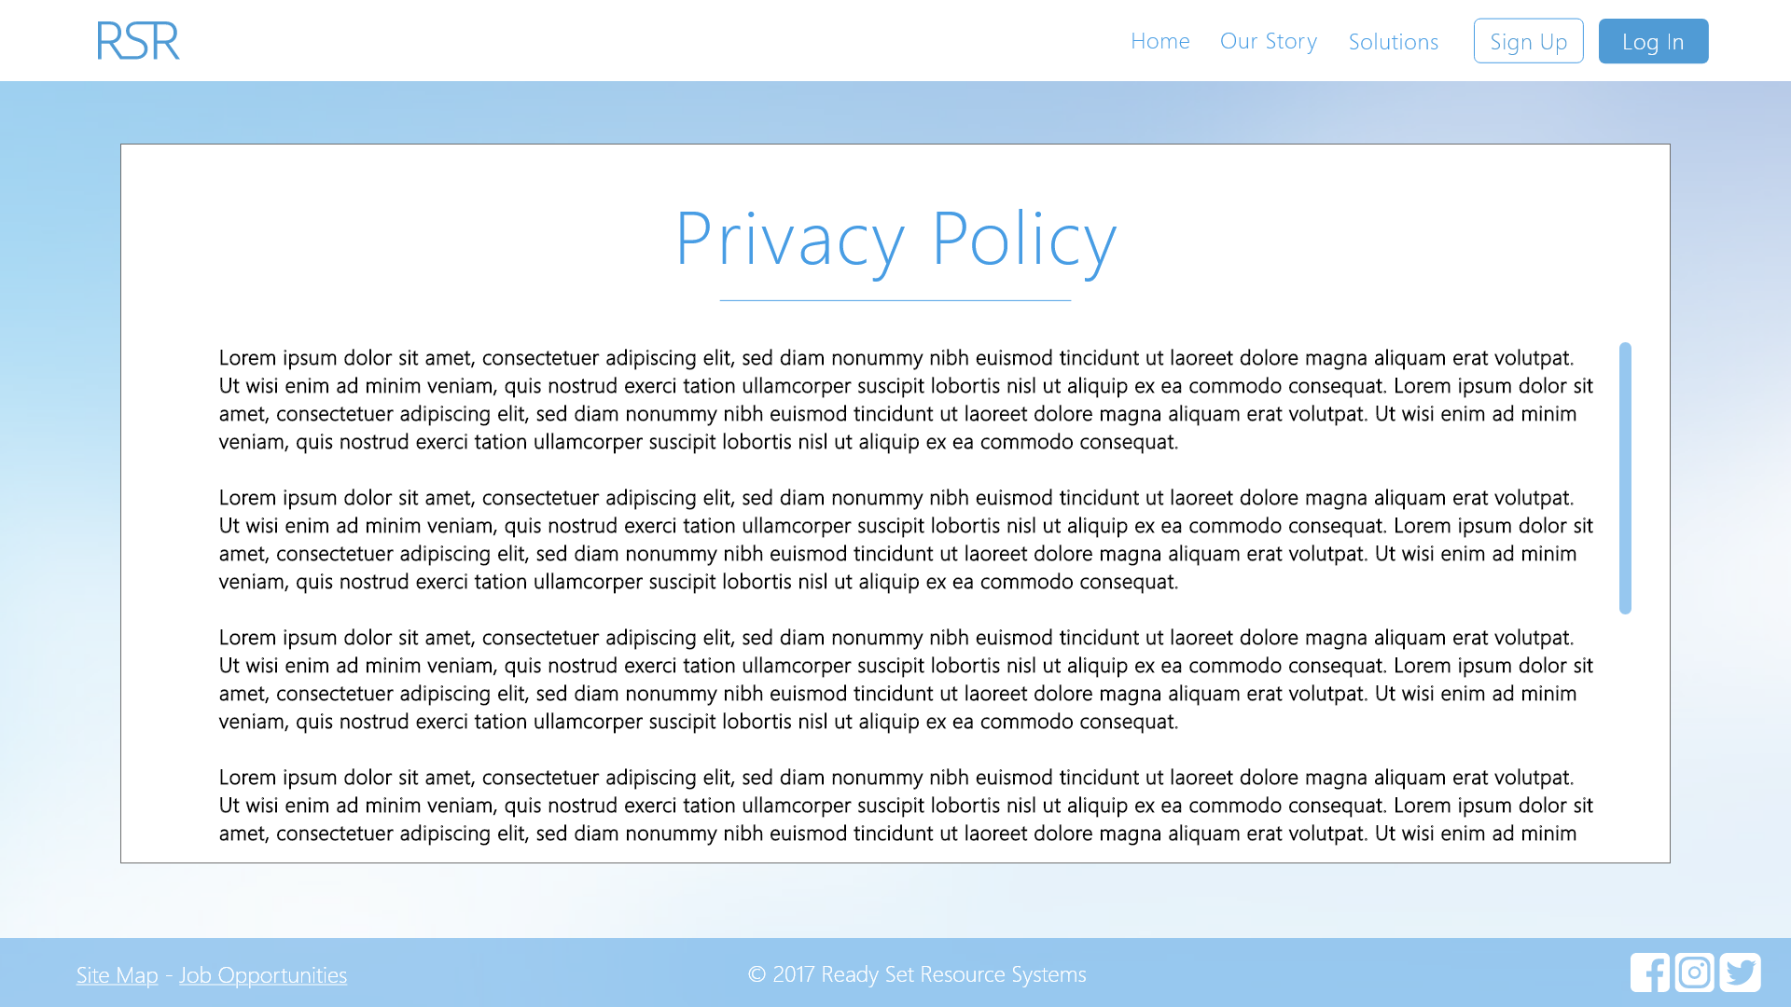

Input Permissible: None

Error Messages: None

# 9.5 - UID /legal/ Work Log

| Entry | Description | Person | Date | Mins Spent |
| --- | --- | --- | --- | --- |
| 1 | Formatted the document | Aidan Marshall | 19/3/18 | 8 |
| 2 | Designed the website | Aidan Marshall | 7/10/17 | 55 |
| 3 | Added screenshots and page details | Aidan Marshall | 7/10/17 | 19 |
| 82 | | | | |